**PROBLEM 2**

**Revised ERD**

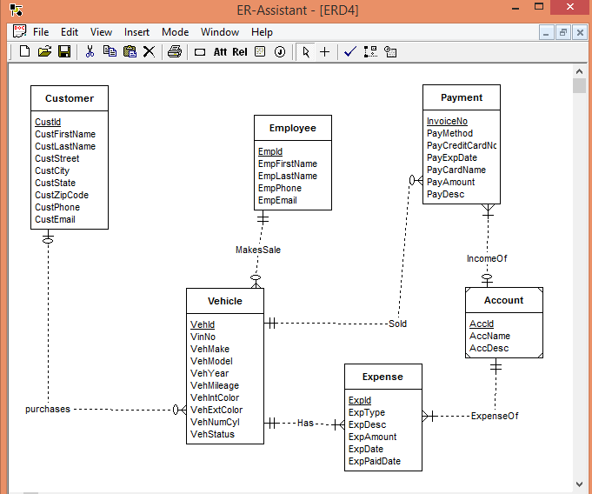

**Design Errors:**

* The minimum cardinality of purchases should be 0 for Vehicle. Because a vehicle can remain on the lot some days before a sale
* The minimum cardinality of sold should be 0 for Vehicle. Because a vehicle can remain on the lot some days before a sale.
* The cardinality of ExpenseOf should be reversed because accounts are related to a collection of expenses.
* The cardinality of IncomeOf should be reversed because accounts are related to a collection of payments.
* Process relationship is redundant.

**Diagram Errors:**

* The minimum cardinality of IncomeOf should be 1 for account because identifying relationships cannot be optional for the child entity type.